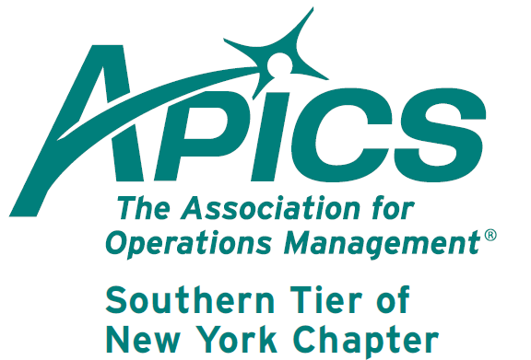
www.stapics.org

NO DINNER MEETING

President’s Message

I recently attended the APICS District meeting (27 chapters in the Northeast US) held in Albany, NY. The second half of the meeting was the annual student case competition. One of our board members, our Director of Education, Don Sheldon, was one of the judges (see his article later in this newsletter).

I was very impressed with the caliber and professionalism of both the graduates and the undergrads. It is refreshing to see ‘new blood’ getting involved with Operations Management, bringing new life to our professions. Don and Brian, our Student Relations Directors, are planning to work with SUNY Binghamton to help us sponsor a team from our area in next year’s competition.

For a review of the competition, go to: http://www.prlog.org\12082756

David B. Gardner CPIM

APICS Update from Don Sheldon, Director of Education

Raymond Tour – We have received a request for a Raymond factory tour and have been supported as usual by our friends at the Greene, NY facility. Raymond Corporation is the premier producer of narrow aisle material handling equipment in North America and a division of Toyota since 2001. We will be facilitating a tour of the Greene facility on April 17th at 6 PM. There will be no cost for this tour and we expect it to take less than 1 hour. (No meal and meeting in April—the tour takes its place). We hope to have a big group to tour this impressive local world class facility. We will meet at the parking lot near the main entrance at 5:45. The main entrance is on the opposite side of the plant from route 12. Hope to see you there.

APICS Student Competition
The last district meeting was held in Albany, NY on 2 February 2012. One of the highlights was the student supply chain problem solving competition. The collegiate teams were given real-life type problems on Friday night and had until noon Saturday to propose operational solutions to help the problem companies succeed in their market. I was one of the judges for the graduate level teams and was very impressed with the presentations. The winners were:

The undergraduate track winners were:
1st Place: UMass Amherst
2nd Place: UMass Amherst
3rd Place: Northeastern University
The graduate track winners were:
1st Place: UCONN
2nd Place: UCONN
3rd Place: UCONN
The grand prize winner which included a trip to Orlando, Fl in September to compete at the APICS International Conference and Exhibition was earned and awarded to: UMass Amherst under graduate team!

We need some local representation in this competition and the board of directors has agreed to support a team from Binghamton University in 2014. Stay tuned.

CPIM Training – We are in discussions with BCC to offer a CPIM series on campus. Cannot share details yet because there aren’t any but hope to be able to soon. I have been contacted by one potential student and am hoping for more interest. More to follow. I can say that it will be a normal fee structure as there is currently no BCC grant money available.

If you are interested in any of the Southern Tier offerings, please contact me at dsheldon@sheldoninc.com. Thanks!

Thanks!
Don
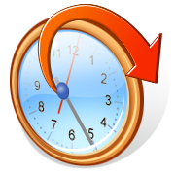Daylight Saving Time Begins Sunday, March 10

We’re on !!!
Come and visit, poke around, or comment on us! Our name there is “Southern Tier APICS”. It’s just another way
for us to keep in touch with our membership.

Board of Directors 2012-2013

President Director of Publicity
Dave Gardner Kelly Norieka
dave@protofab25.com Kelly.norieka@lmco.com

Executive VP /Director of Finance Director of Education
Steve Whited Don Sheldon
steven.whited@acco.com dsheldon@sheldoninc.com

Secretary Director at Large
Debbie Unkel Steve Stanchak
deb.unkel@raymondcorp.com steve.stanchak@infoprint.com

Director of Membership/Director of Chapter Standards/

Director of Online Publication Director of Student Relations
Lee Schechter Brian Arrnold
lschechter@stny.rr.com barnold@amphenol-aao.com

Director of Programming and Marketing Director of Communications
Michael LoSapio April McWeeney
Michael.LoSapio@SynergyResources.net april.mcweeney@acco.com

Southern Tier APICS
PO Box 1107
Binghamton NY 13902-1107

